Pseudocode and Understanding the Rock Paper Scissors problem

understanding the problem, breaking it down, designing a step-by-step solution (algorithm/pseudocode), coding it, testing rigorously, debugging errors, and documenting the process

Understanding the problem:
- We want to create a javascript file (.js) that enables us to play a game of rock, papper, scissors against a computer file
- To do so we will need a few basic steps:
  - User inputs their choice of rock, paper or scissors – input field required
  - Computer randomly selects rock, paper or scissors – using random selection function
    - Math.random()
- function getRandomArbitrary(min, max) {
- return Math.random() * (max - min) + min;
    - Spits out a number inclusive of decimals between 0 and 3
    - Get the number and attribute ranges to each string option rock, paper or scissors
    - If getRandomArbitrary <1 (computerInput === “Rock”)
    - If getRandomArbitrary >=1 && <2 (computerInput === “Paper”)
    - If getRandomArbitrary >=2 (computerInput === “Scissors”)
    - Return computerInput()
  - Computer compares two answers using series of if/else statements
    - If computer = user THEN repeat inputs
    - If computer > user THEN computer wins
    - If computer < user THEN user wins
  - Print winner

The Odin Project Steps
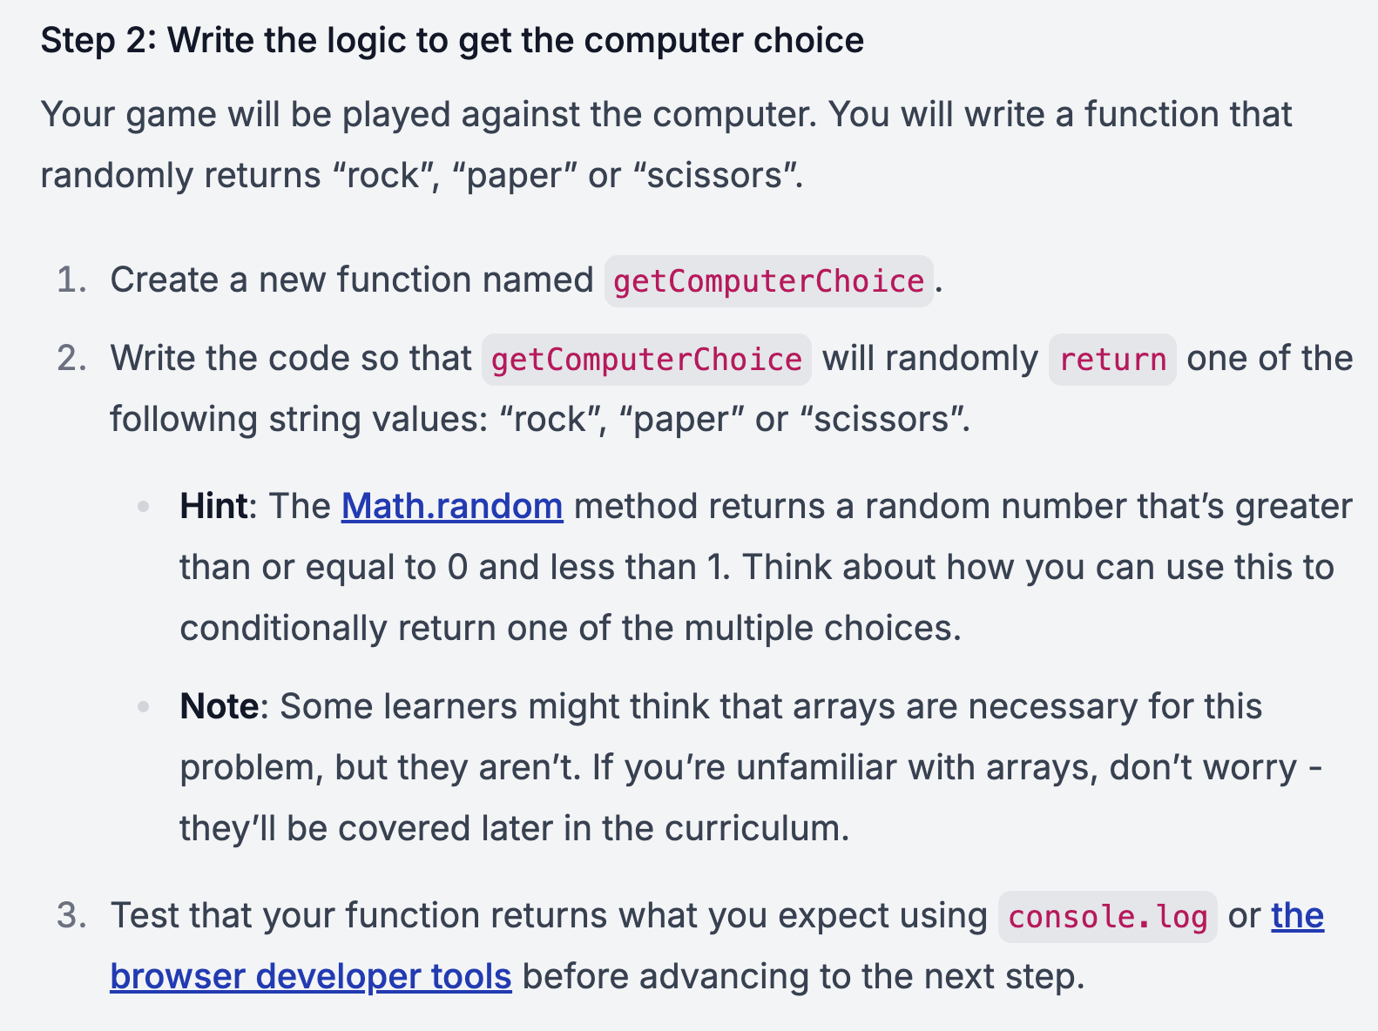
- COMPLETE

